**Project Design Phase-II**

**Data Flow Diagram & User Stories**

|  |  |
| --- | --- |
| Date | 03 July 2025 |
| Team ID | LTVIP2025TMID51397 |
| Project Name | Comprehensive Analysis and Dietary  Strategies with Tableau: A College Food  Choices Case Study |
| Maximum Marks | 4 Marks |

**Data Flow Diagrams:**

A Data Flow Diagram (DFD) is a traditional visual representation of the information flows within a system. A neat and clear DFD can depict the right amount of the system requirement graphically. It shows how data enters and leaves the system, what changes the information, and where data is stored.

**Example:** [**(Simplified)**](https://developer.ibm.com/patterns/visualize-unstructured-text/)

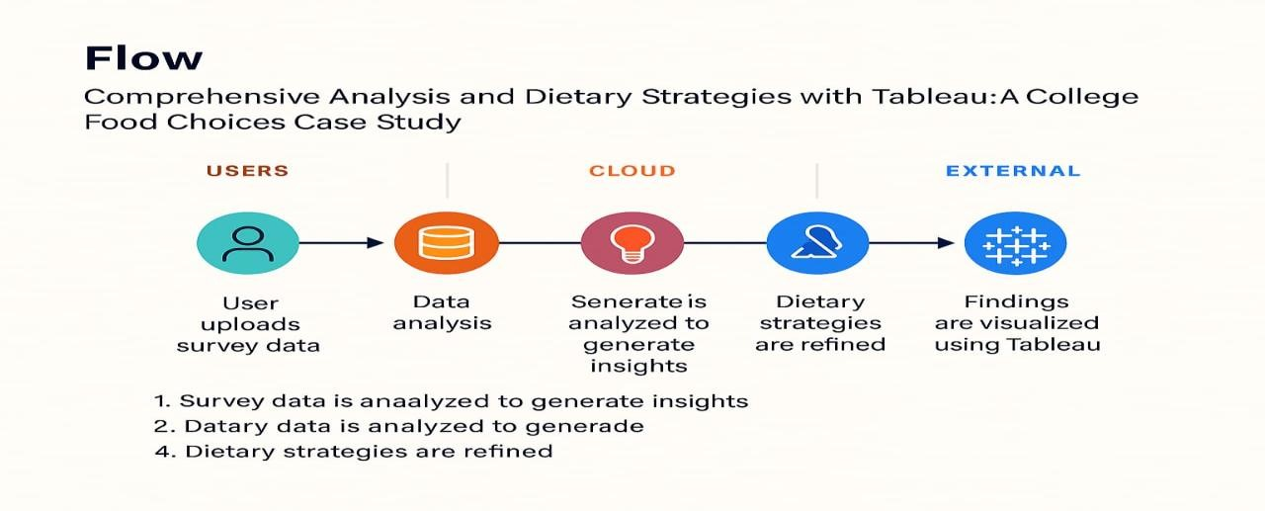

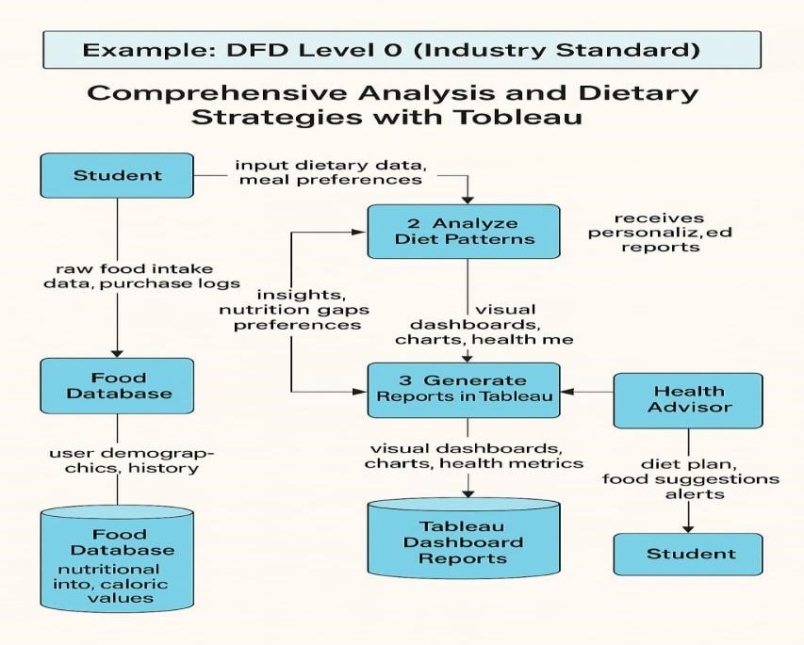

**User Stories**

Use the below template to list all the user stories for the product.

|  |  |  |  |  |  |  |
| --- | --- | --- | --- | --- | --- | --- |
| **User Type** | **Functional**  **Requirement**  **(Epic)** | **User**  **Story**  **Number** | **User Story / Task** | **Acceptance**  **criteria** | **Priori ty** | **Relea se** |
| Student (Mobile/We  b) | Data Entry | USN-1 | As a student, I can input my daily meals including food items and quantities. | I can view and submit a completed meal entry form. | High | Sprint -1 |
| Student (Mobile/We  b) | Visualization  Access | USN-2 | As a student, I can view a visual analysis of my weekly nutrition intake via Tableau dashboard.. | I can access charts showing my calorie and nutrient intake | High | Sprint -1 |
| Student (Mobile/We  b) | Comparison & Suggestions | USN-3 | As a student, I can compare my dietary intake to recommended guidelines and receive suggestions. | I receive personalized dietary tips based on my current intake. | Mediu m | Sprint -2 |
| Nutrition Expert | Data Analysis & Oversight | USN-4 | As a nutrition expert, I can review aggregated data from multiple students for analysis. | I can filter and download collective data for analysis. | High | Sprint -2 |
| College Admin | Reporting | USN-5 | As an admin, I can generate reports on dietary trends among student groups. | I can export reports showing trends, deficiencies, and participation rates. | Mediu m | Sprint -3 |
| Student | Goal Tracking | USN-6 | As a student, I can set personal dietary goals and track my progress over time. | I can view goal progress with visual indicators on my dashboard. | Low | Sprint -3 |
| Student | Feedback & Recommendat  ions | USN-7 | As a student, I can receive automatic feedback based on unhealthy food choices I log. | I see alert messages or tips when I log unhealthy meals. | Mediu  m | Sprint -2 |
| Student | History Tracking | USN-8 | As a student, I can view a history of all my past meal entries and dietary feedback. | I can browse my  past entries by date or week. | Mediu  m | Sprint -2 |
| Nutrition Expert | Custom Rule  Definition | USN-9 | As a nutrition expert, I can define custom dietary rules for students with different needs (e.g., athletes).. | I can add and assign dietary rule sets to specific student categories | Low | Sprint -3 |
| College Admin | Participation Analytics | USN-10 | As an admin, I can view participation metrics by department, year, or gender. | I can filter  participation reports by different demographics. | Low | Sprint -3 |